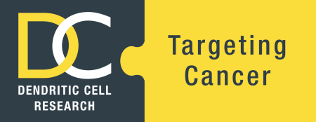
AUGUST 2018 EVENTS REGISTRATION FORM

Personal Details: please print clearly
Title:
Given Name:
Surname:
Preferred Name:
To appear on badge
Email Address:
Registration confirmation & correspondence will be emailed to this address
Position:
Organisation:
Department:
Telephone:
Mobile:
Dietary Requirements:
Vegetarian: | Yes or No
Gluten Free | Yes or No
Other: please specify
Attendance is FREE – Please select which events you would like to attend
Wednesday 8 August – starting at 5.30pm  Professor Derek Hart’s Contribution to Immune Therapies: Continuing his Legacy |  | Yes or No
Thursday 9 August – 8.30am to 5.00pm  DC Down Under Symposium 2018 ‘Immune Therapies…Past, Present + Future’  Networking Drinks and Canapes – 5:00pm – 6:00pm |  | Yes or No  Yes or No
Thursday 9 August – 6.00pm to approx. 9.00pm  Sydney Catalyst Immunology Education Dinner  Note: A copy of this form will be sent to Eve Simons at Sydney Catalyst to contact you regarding this event. |  | Yes or No
Sponsors Listing
Would you like your name, organization and email address included in a listing which will be given to our sponsors? |  | Yes or No

For catering purposes, please register by Friday 20th July 2018

